Karoline Leavitt On Abortion

Highlights:

- Karoline Leavitt opposed Roe v. Wade.
  - Leavitt touted the overturning of Roe v. Wade.
  - Leavitt praised Trump’s Supreme Court picks who voted to overturn Roe v. Wade.

- Karoline Leavitt supported New Hampshire’s abortion ban.

- Karoline Leavitt supported defunding Planned Parenthood.

Leavitt Opposed Roe v. Wade

Leavitt Touted The Overturning Of Roe V. Wade

VIDEO: Leavitt: “I’m One Of The Few Candidates In This Race To Publicly Applaud The Overturning Of Roe v. Wade. According to WMUR via YouTube, “LEAVITT: Well, I am proudly pro-life. And I’m one of the few candidates in this race to publicly applaud the overturning of Roe v. Wade. Because what it did is it returned this right, this issue, back to we the people here in our great state of New Hampshire.” [WMUR via YouTube, 9/6/22]

AUDIO: Leavitt Praised The Overturning Of Roe v. Wade. According to Good Morning New Hampshire via Soundcloud, “LEAVITT: The overturning of Roe v. Wade just returns more power to the people of New Hampshire. It allows our state legislators to pass and govern laws on the issue of abortion as they just did in the recent budget, as you mention Jack, with the 24-week ban. [Good Morning New Hampshire via Soundcloud, 5/10/22]

Leavitt Praised Trump’s Supreme Court Picks Who Voted TO Overturn Roe v. Wade

Leavitt Celebrated Trump’s Supreme Court Nominees. According to a tweet from Karoline Leavitt, “I remember watching the White House Press Corpts Spiral over ACB’s ‘perfect’ confirmation like it was yesterday. Never forget that thanks to President Trump, we have THREE conservative Supreme Court Justices.” [Twitter, @kleavittnh, 10/13/21]

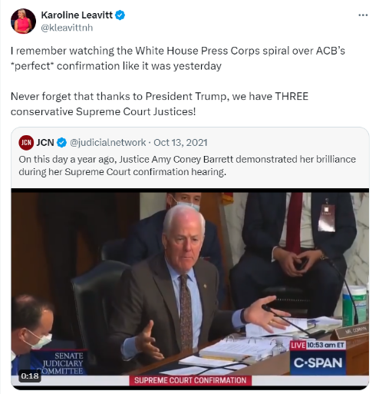
[Twitter, @kleavittnh, 10/13/21]

Leavitt Supported New Hampshire’s Abortion Ban

Leavitt Supported Expanding New Hampshire’s 24-Week Abortion Ban

VIDEO: Leavitt Said She Hoped Lawmakers In New Hampshire Would Expand The State’s 24-Week Abortion Ban. According to WMUR via YouTube, “LEAVITT: Now in our recent budget, as everyone at home watching knows, we passed a 24-week ban on abortion. Personally, I’d like to see that taken a step farther. But I believe in the Constitution and I believe in the Supreme Court’s decision and I hope that we will elect pro-life legislators to the State House in Concord to make those decisions for the people here. [WMUR via YouTube, 9/6/22]

VIDEO: Leavitt On New Hampshire’s 24-Week Abortion Ban: “Personally, I’d Like To See That Taken A Step Farther.” According to WMUR via YouTube, “LEAVITT: Now in our recent budget, as everyone at home watching knows, we passed a 24-week ban on abortion. Personally, I’d like to see that taken a step farther. But I believe in the Constitution and I believe in the Supreme Court’s decision and I hope that we will elect pro-life legislators to the State House in Concord to make those decisions for the people here. [WMUR via YouTube, 9/6/22]

Leavitt Supported Defunding Planned Parenthood

LEavitt Supported Defunding Planned Parenthood

AUDIO: Leavitt: “We Should Defund Planned Parenthood.” According to Good Morning New Hampshire via Soundcloud, "HOST: The executive council, this week by a four to one vote, voted not to accept millions of dollars in federal funding for Planned Parenthood. Do you agree or not agree with that vote? LEAVITT: I absolutely agree with that vote. Thank you to the executive council for making it. And I would like to point out one of my opponents in this race, actually, Russell Prescott, who is a former executive councilor, did vote in favor in his time for accepting money from Planned Parenthood. I think that's egregious. We should defund Planned Parenthood and we should also protect life at all costs. I'm a pro-life candidate. Always will be. Always have been.” [Good Morning New Hampshire via Soundcloud, 7/30/22]

AUDIO: Leavitt Thanked The New Hampshire Executive Council For Their Vote To Refuse Federal Funding For Planned Parenthood. According to Good Morning New Hampshire via Soundcloud, "HOST: The executive council, this week by a four to one vote, voted not to accept millions of dollars in federal funding for Planned Parenthood. Do you agree or not agree with that vote? LEAVITT: I absolutely agree with that vote. Thank you to the executive council for making it. And I would like to point out one of my opponents in this race, actually, Russell Prescott, who is a former executive councilor, did vote in favor in his time for accepting money from Planned Parenthood. I think that's egregious. We should defund Planned Parenthood and we should also protect life at all costs. I'm a pro-life candidate. Always will be. Always have been.” [Good Morning New Hampshire via Soundcloud, 7/30/22]

